

***Introduction***

This curriculum, a joint project of TASC, Hive Learning Network NYC and Mozilla, is a remix of the [Hackasaurus Hacktivity kit](http://hackasaurus.org/en-US/). It provides educators in expanded learning time, after-school and other out-of-school time settings with a free, engaging, web-based model to teach kids how to move from digital consumers to active web producers.

This is a turnkey model that can be quickly disseminated among established after-school and other networks. The materials needed to implement this curriculum are:

* A computer for each student or team of participants
* Internet access
* The most recent version of one of the following browsers installed on each computer:
  + Firefox
  + Google Chrome
  + Safari
* The Hackasaurus X-Ray Goggles installed on the bookmark bar (don’t worry—we’ll tell you how to do this); and
* Kids and a facilitator with basic computer skills. These individuals should know how to operate a computer (turn it on and off), browse the Internet and be familiar with the “copy” and “paste” commands.

The curriculum offers lesson plans for three 45-minute sessions which can be implemented in or out of school. Each lesson plan is preceded by a “How to Begin” section that gives educators information on how to prepare and set up classrooms.

Lesson One introduces participants to hacking. Lesson Two has them dive into manipulating HTML. Lesson Three challenges them to create a STEM-focused webpage. All the lessons may be extended into more than one session, especially the last one. Feel free to use the lessons as written or to tinker with them — that’s what hacking is all about, as you’ll see.

***What is TASCasaurus?***

TASCasaurus is a partnership between TASC, a nonprofit intermediary organization, and Hive Learning Network NYC and Mozilla, the two creators of Hackasaurus. Our goal is to:

* Prepare and motivate community educators to deliver technology-enabled, student-driven learning opportunities using the Hackasaurus tools.
* Use technology to engage youth in a project that will increase both their **digital literacy** and interest in **STEM** (science, technology, engineering, and mathematics[1]).

A pilot project was implemented in six New York City after-school programs to engage kids in 4th to 8th grades to re-mix websites and research STEM content. This curriculum is a result of that collaboration.

Ready? Let’s begin!



***What is Hackasaurus?***

Designed as an **open educational resource (OER)** and an **open source project**, Hackasaurus promotes skills, attitudes and ethics that help youth thrive in today’s **digital age**. By making it easier for tweens and teens to experiment with the building blocks that make up the web, Hackasaurus enables them to move from **digital consumers** to **active producers** who view the web as something that can be constantly remixed and improved.

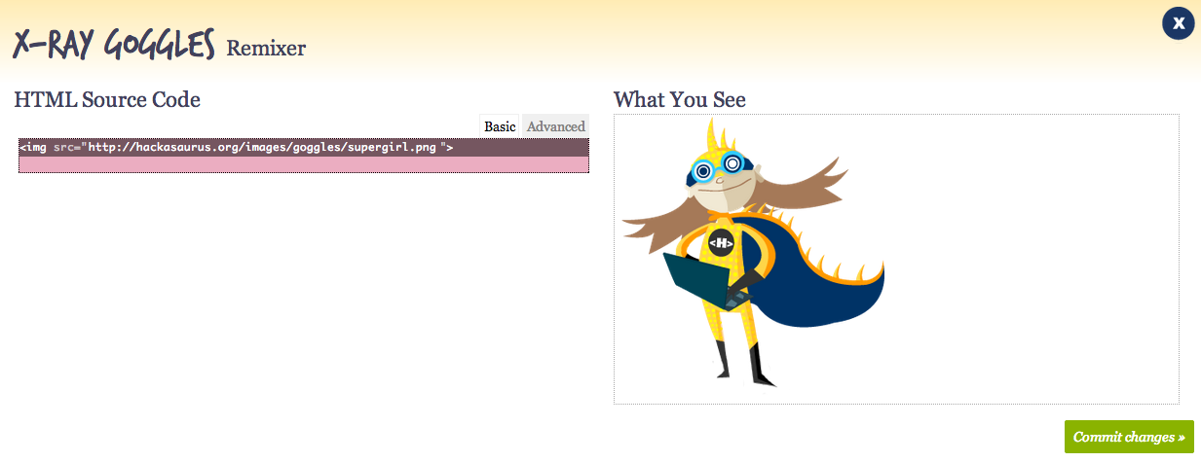

Instead of using “kid-ified” **sandboxes** or **artificial languages**, Hackasaurus lets youth **hack** their favorite web pages using real **programming code**. The **X-Ray Goggles bookmarklet** enables learners to visit any webpage and inspect the code, with **WebPad** (shown above) then allowing learners to take the next step by creating a copy of the **webpage** instantly which can be remixed to alter how it looks.

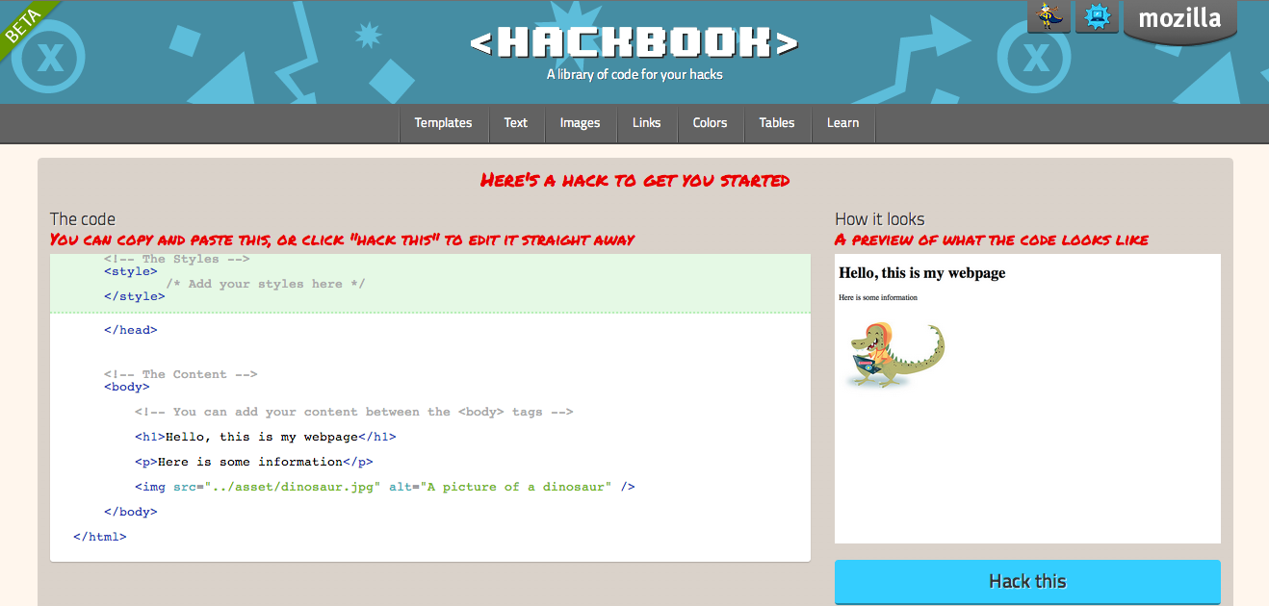

Lastly, the Hackbook (shown above) provides bits of commonly used code for learners to copy and paste. This is only the beginning though, as there are more tools being developed.

***Acknowledgements***

TASCasaurus is a joint effort of [TASC](http://www.expandedschools.org), the [Hive Learning Network NYC](http://www.explorecreateshare.org) and Mozilla. This curriculum is a remix of the [Hackasaurus Hactivity Kit](http://hackasaurus.org/en-US/). We thank the Mozilla Foundation   
and the Joan Ganz Cooney Center for Educational Media and Research for their support of   
this project.



[www.expandedschools.org](http://www.expandedschools.org) [www.explorecreateshare.org](http://www.explorecreateshare.org)

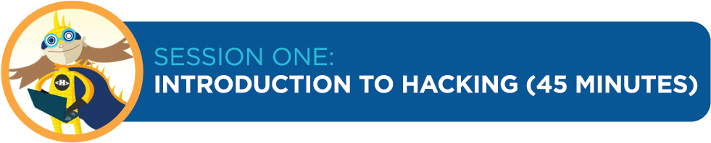

***Lesson Overview***

Participants will “hack a dance” to understand that hacking is a key element of the creative process. Next, they will explore what website code looks like and will try hacking it with the X-Ray Goggles. This helps with future lessons because participants will become comfortable with the idea of hacking and using the goggles.

***Teaching Objective***

Participants will learn:

* That hacking is a key element of the creative process and is a collaborative and constructive activity
* What the code behind a website looks like; how they can change the site using the X-Ray Goggles; and how a website changes when its code is altered

***Materials***

* Chart paper and markers
* One computer per student or small team of students with up-to-date browsers and high-speed Internet access (see *Tips for Classroom Preparation* section)
* X-Ray Goggles installed on each computer; and
* Music for dancing (optional)

***How to Begin – Background and Prep Tips***

1. **FAMILIARIZE YOURSELF WITH RELEVANT TERMS**
   * **Hacking** In this context, hacking refers to remixing content to make new things for the web. Hacking is creative and collaborative. It is not used here to refer to actions that are malicious or illegal.
   * **HTML** Hyper Text Markup Language, one of the codes used to tell computers how to build webpages for human consumption.
2. **UPDATE YOUR BROWSER**
   * Access a computer with high-speed Internet and check to make sure it has the latest version of one of the browsers (to download a browser, click on the link and follow the directions).
     1. Google Chrome (Mac or PC): <https://www.google.com/intl/en/chrome/browser/>
     2. Firefox (Mac or PC): <http://www.mozilla.org/en-US/firefox/new/>
     3. Safari (Mac): <http://safari.soft32.com/free-download?gclid=CPHwkrqntbECFYtV4god0AUAPQ>
3. **INSTALL THE X-RAY GOGGLES**
   * Go to: <http://hackasaurus.org/en-US/goggles/>
   * Try the first hack as shown (optional, but fun!)
   * Scroll down and look for the word “Install “on the left (you may have to hit “Esc” to turn off the goggles first)
   * Click the link and follow it to an installation page. From there, click on the video that shows you how to add the bookmark bar to your browser and follow directions

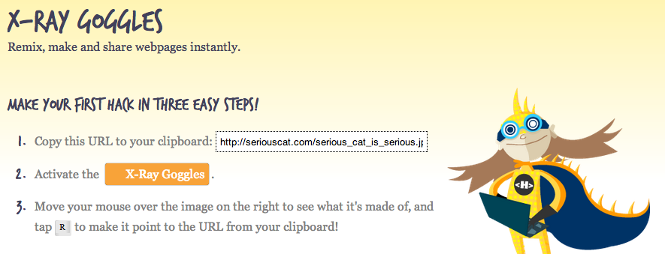

Feel free to play with the Goggles to see how they work. If you wish to teach yourself **HTML** or **CSS** (the basic building blocks of websites), click here: <https://developer.mozilla.org/en/HTML/>. You’ll also learn about these in Session Two.

Work through the lessons, which teach you how to hack and provide you with the opportunity to practice the skills before facilitating your kids' explorations (this is important as it will allow you to try out the various instructions and become familiar with everything.) Don’t worry about not being an expert — everyone will learn and grow together.

Note: For all lessons, you should use websites built with HTML and CSS, because those are the codes you can hack with the Goggles. A few sites you can use:

* + Queens Museum of Art: <http://www.queensmuseum.org/>
  + Brooklyn Arts Council: <http://brooklynartscouncil.org>
  + Prospect Park Zoo: <http://www.prospectparkzoo.com/>

**FOLLOW THESE TIPS FOR CLASSROOM PREPARATION**

1. Set up a welcome table in the front of the room:
   1. The table should include helpful handouts; sign in sheets; guide sheets; posters; a workshop schedule; and other materials you feel are necessary.
2. Set-up participant computers:
   1. Make sure you have enough computers available for participants or teams of participants.
   2. Test the computers to make sure they work.
   3. Make sure all computers are fully charged and/or have a power source.
   4. Make sure the room has a stable Internet connection that can support the number of participants expected.
   5. If necessary, install the most up-to-date version of Firefox, Chrome or Safari on every computer (please note that Hackasarus DOES NOT work on Internet Explorer).
   6. Pre-install the X-Ray Goggles. If the Goggles do not work, it is because the browser you are using is outdated. You may ask students to help you with this.
3. Set-up instructor’s computer:
   1. Install X-Ray Goggles and open all necessary webpages/files for the lesson.
   2. Connect instructor computer to a projector or smart board for teacher intro and demonstration (if available). Note: YOU DO NOT have to have a projector/smart board for the lesson, but it can be helpful.
4. Guide sheets and Resources:
   1. Photocopy guide sheets as required for each lesson (see lesson plans for details)
   2. Identify and have available resources as required for each lesson

***Lesson Outline***

|  |  |  |  |
| --- | --- | --- | --- |
| **Procedure** | **Time** | **Class Configuration** | **Activity** |
| Warm Up | 5 minutes | Entire Class | * Elicit and document participants’ favorite websites and what they would change * Elicit definition of hacking |
| Teach | 10 minutes | Entire Class | * “Hack the Dance” demonstration and discussion |
| Practice | 20 minutes | Partners or in Small Groups | * Practice using X-Ray Goggles with participants partners/small groups |
| Wrap-Up | 5 minutes | Entire Class | * Discuss what hacking is and preview next lesson |
| Extension | If time allows | Partners or in Small Groups | * Participants look up unknown terms and share with class |

***Procedure***

|  |  |
| --- | --- |
| **Warm Up**  *5 minutes*  Gather students on rug or in meeting area | 1. Participants will learn about hacking, be introduced to the X-Ray Goggles and learn to use a tool that enables them to create their own websites.    * Ask participants to raise their hands if they use the Internet, ask what their favorite web page is and chart responses.    * In teams of 2-4, ask participants to take turns bringing up their favorite web page on their computer.    * Have participants tell the group what they like about the page.    * Ask participants if there is something they would change about the page and chart responses.    * Ask participants if they have ever heard of the term hacking, what they think it means and explain that they are going to experience hacking through dance. |
| **Teach**  *10 minutes*  Model what you need students to learn and do.  Keep students on rug or in meeting area | 1. Hack the Dance:    * Have everyone form a circle; turn on music if available.    * Tell the group the name of the dance you are starting with. Show them your step, and have everyone try it. Tell them to think about how they might add to or change the step.    * Ask for a volunteer to add or change the dance, and demonstrate the hacked dance for the other participants.    * Have the person to his/her left hack the dance, and then demonstrate the new dance (it is fine if they need to see a new move again).    * Repeat until everyone in the circle has danced.    * When the last person in the circle has had a chance to hack, everyone should try out the new, completed dance. 2. Discussion questions:    * *Was the end dance the same as the beginning dance?*    * *What should we name our dance now?*    * *Is the original dance destroyed?*    * *What actions were you doing while hacking? (Answers: looked at dance and learned it, changed a step and learned it, changed bits and pieces until it became a new dance, etc.)*    * *What do you think was the goal of the activity? (Answers: creating a new dance by hacking)*    * *What made the dance fun? (Answers: creativity and co-developing the project)*    * *How do you think hacking a dance will be similar to hacking a website? (Answers: changing bits, working together, creating something new)* |
| **Practice**  *20 minutes*  Students move to computers to work independently, in partners or in groups. | 1. Try your X-Ray Goggles:    * Have participants go to their computers and bring up a website they looked at earlier.    * Tell them to look at the toolbar near the top of the screen. Ask them to raise their hands if they see the X-Ray Goggles. Have them help each other if needed.    * Tell them to click once on the Goggles.    * Ask them to move the cursor over part of the page. *Is there a transparent overlay of color?* (If not, the Goggles are not on.) Have them move the cursor around and explore the way things are divided into boxes.    * Look at the edges of the boxes. *What do you see?* (black rectangles with angle brackets{<>} and text) Put your cursor over an image. *What’s in the black rectangle?* (<img>) *What do you think that’s telling you?* (there is an image/picture in this space)    * Have them hover over a piece of text and hit “R” on the keyboard (or click the mouse). *What do they see now?* (The space should expand, and they should now see all the code for that space.)    * *What does it say above the box on the left?* (HTML source code). *What about the box on the right?* (What you see. They might also notice that the box on the left has two tabs—basic and advanced. Tell them we’ll be exploring the advanced tab later.    * In the source code box, highlight the same words you see in the box on the right. Delete them. Now type something else. *What do you see in the box on the right?* (What you have just typed.)    * Click on the “commit changes” button on the lower right. *What happened?* (Your changes now show up on the website.)    * Ask: *Does anyone know what HTML stands for?* (Hyper Text Markup Language.) *What do you think it’s made of? What do you see in the HTML source code box?* (Angle brackets with letters and numbers in them, sometimes also slashes, text, quotation marks.) *What do you think the code does?* (Tells the computer what to put in that space.)    * If there is time, let participants attempt this a few more times. They may also have questions like whether their hacks affect the original website. Remind them of their dance. The original dance still exists, along with the hacked dances. |
| **Wrap-Up**  *5 minutes*  Students come back to meeting area to discuss what was learned. | * Review how you turn on the X-Ray Goggles (click on them), how you know when they are on (there is a transparent overlay of color when the cursor is placed over an area), what was in the box on the left after you hit ‘R’ (HTML source code), how you make the changes show up on your website (click on ‘commit changes’ button) and how it feels to remix the site. * Tell participants in the next session, they will learn more about HTML and how to change pictures. Ask them to think more about how they would like to change a website. |
| **Extension**  *Time as needed*  Students who are finished can work together on this activity or it can be continued another day. | * Ask participants to come up with questions about what they learned during the lesson or on Hackasaurus in general. * Hand out FAQ’s and have participants try to answer them. * If the answers aren’t in the FAQ’s, have participants research the answers on the Internet. * Have students share their information. |



***Lesson Overview***

Participants are introduced to terms, code examples and tools related to basic HTML. Activities demonstrate browser basics, web authoring and tool competencies.

***Teaching Objective***

Participants will learn:

* What an HTML element is
* How to read HTML code
* How to hack pictures

***Materials***

* One computer for leader demonstration. (Internet connection preferable)
* One computer per student or small team of students, with up-to-date browsers and high-speed Internet access (see *Tips for Classroom Preparation* section)
* Guide sheets and resources

***How to Begin – Background and Prep Tips***

1. **FAMILIARIZE YOURSELF WITH RELEVANT TERMS**

* **Code** A system of words, letters, figures, or other symbols used to represent others. Various types of code are used in programming languages that build the digital tools we use every day.
* **HTML (Hyper Text Markup Language)** A commonly used code for building webpages
* **CSS (Cascading Style Sheets)** A code used to alter the appearance of webpages. CSS manipulates HTML elements to add color and style.
* **Web page** Combination of HTML, CSS, graphic assets and text content
* **Tag** Words, letters, numbers, or symbols surrounded by angle brackets (<>).Pairs of tags form the *elements* of HTML code. Closing tags include a backslash (/).
* **Element** An opening tag (e.g.<p>) and its corresponding closing tag (e.g. </p>) and the content in between, such as text or pictures. HTML elements are the building blocks of webmaking.

*For a fuller list of terms, visit* [*https://developer.mozilla.org/en-US/learn*](https://developer.mozilla.org/en-US/learn)

1. **FAMILIARIZE YOURSELF WITH USING BASIC CODE**

The more practice you have with code, the better. If you would like to work through a basic tutorial on HTML or CSS, try one of these sites:

* <http://www.w3schools.com>
* <https://developer.mozilla.org/en-US/learn>
* <http://www.tizag.com/>

1. **FAMILIARIZE YOURSELF WITH KEYBOARD SHORTCUTS AND IMAGE FILES**

It is important to be able to identify the different types of common image files such as .jpg, .png and .gif. These letters will show up at the end of a URL if it directs to a specific image. Practice replacing images on webpages as much as possible (directions are in the lesson).

Review Keyboard Commands for Macs and/or PC’s. It is essential that you know how to cut and paste text. You may use mouse or keyboard shortcuts such as;

* Macintosh: Copy: Command + C, Paste: Command + V
* PC: Copy: CTRL + C, Paste: CTRL + V

1. **FOLLOW THESE TIPS FOR CLASSROOM PREPARATION**

* Print guide sheets:

It is helpful to have guide sheets printed and available for participants   
to follow. You may use the ones from the Hacktivity kit or create your own. Here are list of the ones attached to this lesson:

1. HTML Examples (attached to this lesson plan)
2. HTML guide Sheet (<http://labs.toolness.com/temp/hackasaurus-pdfs/hacktivity_kit.pdf> (pgs 35 and 36))
3. CSS guide Sheet (<http://labs.toolness.com/temp/hackasaurus-pdfs/hacktivity_kit.pdf> (pgs 35 and 36))
4. X-Ray Goggles guide Sheet (<http://labs.toolness.com/temp/hackasaurus-pdfs/goggles_cheatsheet.pdf> (pg 37))
5. Design Challenge (attached to this lesson plan)
6. “Decode The Code” Activity (attached to this lesson plan)

* Have resources available:

Identify online resources that participants may use while they are learning about HTML and CSS. It may be helpful to have the resource links listed on paper and/or opened on the browser of the computer where you are demonstrating. Here are a few links that may help with learning code:

* + 1. <http://www.w3schools.com/>
    2. <https://developer.mozilla.org/en-US/learn>
    3. <http://www.tizag.com/>
* Set-up instructor’s computer:

1. Open all necessary webpages/files for the lesson.
2. Connect instructor computer to a projector or smart board for teacher intro and demonstration (if available). Note that YOU DO NOT have to have a projector/smart board to conduct this lesson.

***Lesson Outline***

|  |  |  |  |
| --- | --- | --- | --- |
| **Procedure** | **Time** | **Class Configuration** | **Activity** |
| Warm Up | 5 minutes | Entire Class | * Review what HTML is * Elicit what characters are in the code * Have kids look for patterns in code using "HTML examples" sheet |
| Teach | 15 minutes | Entire Class | * “Decode the Code” Have kids work in groups with this sheet and the HTML guide sheet to figure out what the code means * Introduce digital images and take kids through their first image hack. |
| Practice | 20 minutes | Individuals, Partners or in Small Groups | * Practice looking at html with the X-Ray Goggles * Have kids try hacking images, text, and (as ready) links * Have kids play with changing code * Report out, and start a list of questions/issues |
| Wrap-Up | 5 minutes | Entire Class | * Discuss the lesson and go over questions. |
| Extension | If time allows | Partners or in Small Groups | * Introduce CSS * Show how to activate CSS on goggles, hand out CSS guide sheets and let kids explore |

***Procedure***

|  |  |
| --- | --- |
| **Warm Up**  *5 minutes*  Have students seated in groups or at individual stations so they can see you. | 1. Introduction to HTML tags:  Participants will review what they learned about HTML and look for patterns in the way the code is used.   * + Ask participants to raise their hands if they remember what HTML is (Hyper Text Markup Language). *What does it do?* (Tells the computer what to put in that space.)   + Ask if anyone remembers some of the things that made up the code. Have kids come up and write what they remember on the board or on chart paper.   + Hand out the “HTML Examples” sheet and ask participants to work in groups to compare them and look for patterns.   + Ask: *What do these examples have in common? What patterns did you find?* (All start and end with angle brackets, some have web addresses in them, some have quotation marks, some repeat the opening bracket but with a forward slash.)   + Tell them that what they are looking at are HTML “tags.” *Tags are always enclosed in angle brackets, and often come in pairs. The opening tag tells the computer to start something (for example, a paragraph or italic font), and the closing tag (with the forward slash) tells the computer to stop.* It might be helpful to write out the parts as you speak about them (e.g. <>, </>). |
| **Teach**  *15 minutes*  Students can stay in groups or at individual stations. It is important that they can see examples as you refer to them.  Have students move to their computers | 1. Decode the code:    * Is anyone curious about what the code is actually telling the computer to do? Hand out HTML guide sheets and "Decode the Code." Ask students to work in small groups to interpret the code. Give them crayons or markers so they can translate the HTML into words and images.    * Have each group show one of their interpretations and explain it (e.g., “We put this sentence in bold because right before it was <b> and right after it was </b>".) It may be easier for them to write the tags than to describe them. 2. Introduce digital images to the group:    * Explain that if they see .jpg, .png or .gif it implies that they are looking at a digital image that has been uploaded to the web. You may choose to show them an example of this.    * Tell them we’re going to try the x-ray goggles again, and this time we’ll try to change a picture on a website. To do that, you’ll have to search for a picture you like on the web (try googling for images), then right click and select “copy image url” from the menu. When you get back to your site, you’ll replace the current picture url with the new one.    * Tell participants to open the Great Science for Girls website (www.gsg.org) and activate their goggles. Tell them we are using this site because it uses mostly HTML, so is easy to practice on.    * Have them move the cursor until they find an image. *Click on the image so it expands and you can see the code.*    * Say: *Now open a new tab and search for an image of your favorite animal (e.g., enter "pictures of Koga the gorilla" in the search box).*    * *Right-click on one of the images, and then select "copy image url." (If that choice doesn't show up, choose another image.)*    * *Go back to Great Science for Girls. Remember we talked about the "Basic" and "Advanced" tabs? Click on the advanced tab.*    * *Do you see where it says <img src=?*    * *After the equal sign, notice the quotation marks. What's inside of them?* (Something beginning with http and ending with .jpg, .png or .gif.)    * *That's the link to the image you see on the page, and that's what you are going to change. You need to keep the tags and the quotation marks, so make sure you highlight just the image url.*    * *Got it? Now right-click and select "paste".*    * *Has your image changed?*    * If some kids are having problems, ask others to help trouble-shoot. Possible issues: they didn't select "copy image url"; they highlighted more than just the url (e.g., they took out the quotes as well); they didn't select the entire url.    * As you and the kids work to solve the problems, reassure them that messing around and making mistakes is a great way to figure out how this works. |
| **Practice**  *20 minutes*  Students work at computers independently, in partners or in groups. | 1. Play with hacking code, images, and text:    * Tell youth to continue experimenting with changing text, pictures and code.    * *On the basic tab, you can only hack content—text and pictures. The advantage is that you won’t accidentally delete or change the code.*    * *However, I’d like you to deliberately change the code, using the advanced tab. Go ahead! What happens if you delete a closing tag? What happens if you substitute an “i” for a “b”? Is the <p> tag really necessary?*    * *Please write down what you’ve tried and what happened so we can discuss. And if things get completely out of hand, just close the box and start over.*    * *Make sure you hack at least one image and one piece of text.*    * *Remember that this is a collaborative. It’s okay to give help and need help.*    * If they are ready, tell youth they can hack links following a similar procedure as for pictures. *In the code, locate the tag that indicates a link (<a href=”http:websiteurl”descriptivetext</a>) and replace the url with another. You can also change the descriptive text.*    * After they have explored for 15 minutes or so, ask teams to report out on their experiences. What did they change and what happened? Where did they have problems? You might want to start a chart of problems and questions. When all have reported out, look at your chart and ask if anyone was able to solve any of these problems or answer the questions. Cross off those that have been solved or answered, and say: *We’ll work together to figure out the rest over time.* |
| **Wrap-Up**  *5 minutes*  Students reflect on the lesson. | 1. Review HTML terms, elements and concepts. 2. Tell participants that in the next session, they will be able to do a fun project where they build their own STEM-based website. |
| **Extension**  *Time as needed*  Students can do their own “Decode the code” challenge with the remaining time. | * Introduce CSS (Cascading Style Sheets), used to add style to HTML * Hand out CSS guide sheets, show kids how to activate CSS with their goggles:   + turn x-ray goggles on and roll over a specific area of the website you want to hack   + hold the "c" down and press the space bar   + a dark grey window will pop up. Edit the styles you see in the window * Let kids explore. Those who would like more information can go to: https://developer.mozilla.org/en-US/docs/CSS/Getting_Started/How_CSS_works |

***Materials for this Lesson***

**GUIDE SHEETS**

The following documents are meant to be handed out and/or used a lesson guides.

1. HTML Examples
2. HTML Cheat Sheet
3. CSS Cheat Sheet
4. “Decode The Code” Activity

 

**HTML EXAMPLES**











***Lesson Overview***

Participants are introduced to biodiversity. They examine and document local bio facts such as leaves, stones, and feathers, and use their documents and online research to begin a website about local (or broader) biodiversity.

***Teaching Objective***

Participants will learn:

* What biodiversity is and why it’s important to humans
* How to upload a picture or drawing for insertion in a website
* How to use direct observations and online research to create a website

***Materials***

* Paper, pencils, digital camera/camera phone or video recorder
* Examples of local biodiversity found outside (leaves, plants, seeds, insects, etc.)
* One computer per student or small team of students with up-to-date browsers and high-speed Internet access (see *Tips for Classroom Preparation* section);
* Guide sheets and resources

***How to Begin – Background and Prep Tips***

1. **FAMILIARIZE YOURSELF WITH RELEVANT TERMS**

STEM fields are both widely divergent and interconnected, and offer many opportunities for investigation. This lesson focuses on *biodiversity*, so the terms below are relevant to that topic. At the end of the lesson are resources for exploring other STEM fields. Feel free to substitute any of those as the focus for this lesson.

* **Biodiversity** The variety of life on our planet; there may be over 100 million species on Earth, but only 1.7 million have been identified
* **Ecosystem** An interacting network of living and non-living parts of a particular area; ecosystems include plants, animals, bacteria (living parts), weather, soil, nutrients (non-living parts), etc.
* **Species** A group of organisms that can reproduce with each other (e.g., dogs and cats are different species because they cannot interbreed, but beagles and dachshunds are the same species because they can)
* **Ecological Services** Functions of a healthy ecosystem that support life, for example oxygen production, decomposition of wastes, purification of water, nitrogen fixing
* **Endangered** A species is considered endangered if it is at risk of becoming extinct. Habitat destruction, over-hunting, and introduced species are three major reasons species become endangered.
* **Extinction** The end of a species; no individuals of a species exist; for example, dinosaurs became extinct about 65 million years ago

1. **GATHER SEVERAL STEM RELATED WEBSITES FOR STUDENTS TO HACK**

Find some interesting STEM related websites that students may enjoy hacking. Use x-ray goggles to see if they are built with HTML and CSS. If they are not built with either you will not be able to alter them with Hackasaurus and therefore should not use them as examples. Here is a short list of STEM websites built with HTML and CSS:

* Periodic Table: <http://www.ptable.com/>
* Prospect Park Alliance: <http://www.prospectpark.org/environment/wildlife>
* NYC Botanical Garden: <http://www.nybg.org/gardens/thain-family-forest/index.php>
* Hack the Brain: <http://www.princetonbrainandspine.com/subject.php?pn=brain-anatomy-066>
* Great Science For Girls: <http://www.greatscienceforgirls.org/>

1. **HAVE RESOURCES RELATED TO BIODIVERSITY/CONSERVATION AVAILABLE**

There are many organizations with information about biodiversity; a small selection is listed below. Some even offer opportunities to participate in Citizen Science projects. See also several of the resources in the section above. For resources specific to your location, try searches such as "urban biodiversity *my city*"; "suburban biodiversity *my area*"; "rural biodiversity *my area*"

* National Wildlife Federation: <http://www.nwf.org/wildlife/wildlife-conservation/biodiversity.aspx>
* Project Noah: [www.projectnoah.org](http://www.projectnoah.org)
* United Nations Environment Programme: <http://www.unep.org/urban_environment/issues/biodiversity.asp>
* The Nature of Cities: <http://www.thenatureofcities.com/2012/08/14/discovering-urban-biodiversity/>
* Natural History Museum, London: <http://www.nhm.ac.uk/nature-online/biodiversity/>

1. **COLLECT LOCAL BIOFACTS: LEAVES, INSECTS, FEATHERS, SHELLS, ETC.**

These are for the youth to examine and document as evidence of local biodiversity. Alternatively, you can ask each participant to bring in a few biofacts, or take a neighborhood walk to collect/record them. If you choose to take a walk, this will take an entire session. Proceed with the lesson below the next time you meet.

1. **PRACTICE UPLOADING PICTURES TO THE WEB**

In the previous session, you learned how to recognize pictures and how to copy those already uploaded. There are many ways to upload pictures to the web, but below is one simple method.

1. Open a flickr account (<http://www.flickr.com/>)
2. Upload your pictures/drawings to your new flickr account (they must be in .jpg/.png format).
3. Copy image URL (MAC: control+click PC: right mouse click) of each image on flickr and paste it into the hacking window using x-ray goggles.

*Please note*: You should discuss with your supervisor how to provide access to flickr. You may want to open one account that all the youth can use, e.g." PS zzz afterschool," rather than having each person open her own. Also make sure to choose the privacy settings you want. The uploaded pictures can be available publicly or kept private.

1. **FOLLOW TIPS FOR CLASSROOM PREPARATION**

* Provide list of STEM websites:

It is helpful to have a list of websites for students to begin hacking and for research. You may print these on individual guide sheets and/or display them on a wall, chalkboard or smart board. See above for suggested sites, or use others familiar to you.

* Have resources available:

Identify online resources that participants may use while they are building new websites

1. <http://www.w3schools.com/>
2. <https://developer.mozilla.org/en-US/learn>
3. <http://www.tizag.com/>

* Set up instructor’s computer:
  1. Open all necessary webpages/files for the lesson.
  2. Connect instructor computer to a projector or smart board for teacher intro and demonstration (if available). Note: YOU DO NOT have to have a projector/smart board.
* Set up a flickr account for uploading pictures:
  1. Ideally, your youth will be able to scan/download pictures onto the computers as they create them.
  2. If not, create and download in advance pictures of the objects for the youth to upload to flickr. You should have at least one picture for each person/team to upload for practice.
  3. Note: pictures must be in .jpg or .png format. If you scan drawings, make sure to save them in one of those formats.

***Lesson Outline***

|  |  |  |  |
| --- | --- | --- | --- |
| **Procedure** | **Time** | **Class Configuration** | **Activity** |
| Warm Up | 5 minutes | Entire Class | * Show a local biofact and ask what  it is * List other species/items youth have noticed in their surroundings * Introduce the term "biodiversity" |
| Teach | 15 minutes | Entire Class | * Introduce the local biofacts, and have participants draw or take pictures of them * Lead youth in uploading their pictures to Flickr or another photo sharing resource * Have them replace a picture on a website with the picture they just uploaded |
| Practice | 20  minutes | Individuals, Partners or in Small Groups | * Offer youth additional resources for learning about biodiversity * Have the class start to insert their research, photos and writing into a website using x-ray goggles. You can decide what website they hack. (Websites built entirely with HTML/CSS are the best). |
| Wrap-Up | 5 minutes | Entire Class | * Class reflection. Gather questions and comments. Assign students to continue their biodiversity websites at home and/or at school |
| Extension | If time allows | Partners or in Small Groups | * Have individuals or groups think about other STEM topics they'd like to build websites around |

***Procedure***

|  |  |
| --- | --- |
| **Warm Up**  *5 minutes*  Have students seated in groups or at individual stations so they can see you. | 1. Local biodiversity:   Participants will think about what kinds of living and non-living natural things they notice in their environment.   * + Show one artifact (a leaf, a stone, a feather) and ask: *What is this? Where do you think I got it? Is it part of the natural world, or human-made? Living or non-living?*   + Say: *Let's name all the natural things we've seen in our neighborhood.* Have one youth chart the living things, and another the non-living. Note that "living' includes things that were alive at one time; therefore a feather would be classified as living.     1. If you think it would be helpful, have them chart everything in their environment, and have three charts: natural living, natural non-living, and human made   + Say: *The number of living species is called biodiversity. Do you think we have high, medium, or low biodiversity in our area?* |
| **Teach**  *15 minutes*  Youth research and document biodiversity, and practice uploading pictures  Students can remain where they are until it is time to upload, then will move to the computers | 1. Document local biodiversity and introduce webpage and picture uploading:    * Say: *We are going to learn about biodiversity and create a webpage about it, using the X-Ray Goggles and the skills you've practiced previously. We're also going to learn how to upload our own pictures to use on our websites.*    * Say: *Let's start by examining some biofacts from our area.* Display your collection, and ask the class to begin researching and documenting them. Encourage them to start by taking pictures or making drawings, so they can learn how to upload them for use on their websites.    * As people complete their drawings/pictures:      1. have youth scan the drawings and download the photos as they create them      2. OR use previously downloaded pictures of the objects    * Say: *Now we'll learn how to upload those pictures to the web and use them to replace another picture on our website.*    * Ask: *Does anyone remember how we replace pictures on a website?* (Find a picture, right-click and select "copy image url", paste that url over the one in the website, making sure to keep the quote marks in but take out all of the old url)    * Explain that we are going to use a photo website called Flickr. Have them go to the site (http://www.flickr.com/) and either create an account or login to the account(s) already created for their use. Discuss the importance of controlling public access to their pictures, and ask everyone to make sure the account allows only private access.    * Tell them to click on "Upload Photos and Video." They can then either drag and drop or select pictures from a file. Note that if they try to upload something that is not in the right format (.jpg, .png) they will get an error message. Have youth help each other if some are having difficulties.    * When ready, have them move their cursor over a newly uploaded folder, right click, and select "copy image url".    * Tell them to complete the transfer as they have previously: open a webpage, turn on the goggles, and paste the new url over the old. Make sure everyone is able to do this, and engage youth in helping each other. |
| **Practice**  *20 minutes*  Students remain at computers to work independently, in partners or in groups. | 1. Create a website:    * Tell group they are now going to begin putting together their biodiversity websites.    * Ask the class to research and plan, beginning with their bio facts. Provide books and a list of websites for online research, but encourage them to search for additional sites.    * Tell students they need to use a site built with HTML and CSS--the two languages we've learned. Suggest they use one of the following sites:      1. Queens Museum of Art: <http://www.queensmuseum.org/>      2. Brooklyn Arts Council: <http://brooklynartscouncil.org>      3. Prospect Park Zoo: <http://www.prospectparkzoo.com/>  * *Note:* You may need to use more than one session to complete the research and websites. |
| **Wrap-Up**  *5 minutes*  Students reflect on the lesson. Determine how much more time is needed to complete website. | 1. Close out the Website:    * Find out where the students are with building their biodiversity websites. Ask: *Would you like to be able to save this site and return to it?*    * Say: *To save your site, hit the "publish to Internet" button. Open your published site in a new window, then copy the url in the address bar and save it somewhere. This is how you can get back to this page and change it, or share it with friends.*    * Ask if there are any questions or comments. Ask participants to raise their hands if they feel they could improve their sites in the next session. |
| **Extension**  *Time as needed*  Students continue working on their biodiversity websites | * Ask students if they know what STEM means (science, technology, engineering, math). *Is biodiversity a STEM topic*? *What other STEM fields do you know about?* * Give students some STEM websites and ask them to list three STEM topics they'd like to create websites about. Ask them to explain why they are interested in those topics. |

***Resources for this Lesson***

The following links can be shown to class and/or used a lesson guides.

1. Biodiversity for kids lesson plan: <http://www.environment.nsw.gov.au/resources/education/BiodiversityTeachersGuide.pdf>
2. STEM – Works

<http://www.stem-works.com/>

1. PBS STEM for Teachers

<http://www.pbs.org/teachers/stem/>

1. Flickr photo sharing site: for uploading your own pictures/images to the web.

<http://www.flickr.com/>

1. *What is STEM?*

   “STEM” is an acronym of science, technology, engineering, and mathematics. It encompasses a wide array of topics and professional fields. An official list of STEM disciplines does not exist, but the [U.S. Immigration and Customs Enforcement](http://en.wikipedia.org/wiki/U.S._Immigration_and_Customs_Enforcement) lists disciplines including:

   |  |  |  |
   | --- | --- | --- |
   | * Physics * [Actuarial Science](http://en.wikipedia.org/wiki/Actuarial_Science) * [Chemistry](http://en.wikipedia.org/wiki/Chemistry) * [Mathematics](http://en.wikipedia.org/wiki/Mathematics) * [Statistics](http://en.wikipedia.org/wiki/Statistics) * [Computer Science](http://en.wikipedia.org/wiki/Computer_Science) * [Psychology](http://en.wikipedia.org/wiki/Psychology) * [Biochemistry](http://en.wikipedia.org/wiki/Biochemistry) * [Robotics](http://en.wikipedia.org/wiki/Robotics) * [Computer Engineering](http://en.wikipedia.org/wiki/Computer_Engineering) | * [Electrical Engineering](http://en.wikipedia.org/wiki/Electrical_Engineering) * [Electronics](http://en.wikipedia.org/wiki/Electronics) * [Mechanical Engineering](http://en.wikipedia.org/wiki/Mechanical_Engineering) * [Industrial Engineering](http://en.wikipedia.org/wiki/Industrial_Engineering) * [Civil Engineering](http://en.wikipedia.org/wiki/Civil_Engineering) * [Aerospace Engineering](http://en.wikipedia.org/wiki/Aerospace_Engineering) * [Chemical Engineering](http://en.wikipedia.org/wiki/Chemical_Engineering) * [Astrophysics](http://en.wikipedia.org/wiki/Astrophysics) * [Astronomy](http://en.wikipedia.org/wiki/Astronomy) * [Optics](http://en.wikipedia.org/wiki/Optics) | * Nuclear Physics * Mathematical Biology * Operations Research * Neurobiology * Biomechanics * Bioinformatics * Acoustical Engineering * Geographic information Systems * Atmospheric Sciences * Nanotechnology |

   The National Science Teachers Association (NSTA) explains that “STEM education is an interdisciplinary approach to learning where rigorous academic concepts are coupled with real-world lessons as students apply science, technology, engineering, and mathematics in contexts that make connections between school, community, work, and the global enterprise enabling the development of STEM literacy and with it the ability to compete in the new economy.”

   The United States Department of Education is encouraging more students, teachers, and practitioners to specialize in the STEM fields. NSTA states that “American industries need more workers in these fields due to an aging workforce and an increasingly innovative world market.” TASCasaurus aims to bridge the gap between STEM education and professional applications through hands-on engagement and fun activities.